**Plate D**

**Supplier:** 4titude Limited

**Product Description:** Vision Plate 96, black, clear base, sterile

**CAT Number:** 4ti-0223

**Material:** Polystyrene

**Plate C**

**Supplier:** Greiner Bio-One

**Product Description:** Microplate, 96 well, UV-Star®, COC, F-Bottom, Chimney Well, Black, µClear®, 10 ST./BTL.

**CAT Number:** 655809

**Material:** Cycloolefine

**A**

**Plate B**

**Supplier:** Corning Inc.

**Product Description:** Corning® 96-well Black/Clear Flat Bottom Polystyrene NBS Microplate, 25 per Bag, without Lid, Nonsterile

**CAT Number:** 3651

**Material:** Polystyrene treated with proprietary nonbinding technology

**Plate A**

**Supplier:** 4titude Limited

**Product Description:** UltraVision Plate 96, clear, non-sterile with UV base

**CAT Number:** 4ti-0234

**Material:** Polystyrene, base of wells made with proprietary material

|  |  |  |  |  |
| --- | --- | --- | --- | --- |
| **Protein:Ligand Pair** | **Dialysis** | **Plate Type** | **kD Mean (uM)** | **kD SD (uM)** |
| **p38:Bosutinib** | No | 4ti-0234 | 6.5 | 6.3 |
| **p38:Bosutinib** | Yes | 4ti-0223 | 0.0115 | 0.5508 |
| **p38:Bosutinib Isomer** | No | 4ti-0234 | 24.6 | 23.4 |
| **p38:Bosutinib Isomer** | Yes | 4ti-0223 | 3.8 | 25835.5 |
| **p38:Erlotinib** | No | 4ti-0234 | 3600 | 194600 |
| **p38:Erlotinib** | Yes | 4ti-0223 | 16.7 | 29.2 |

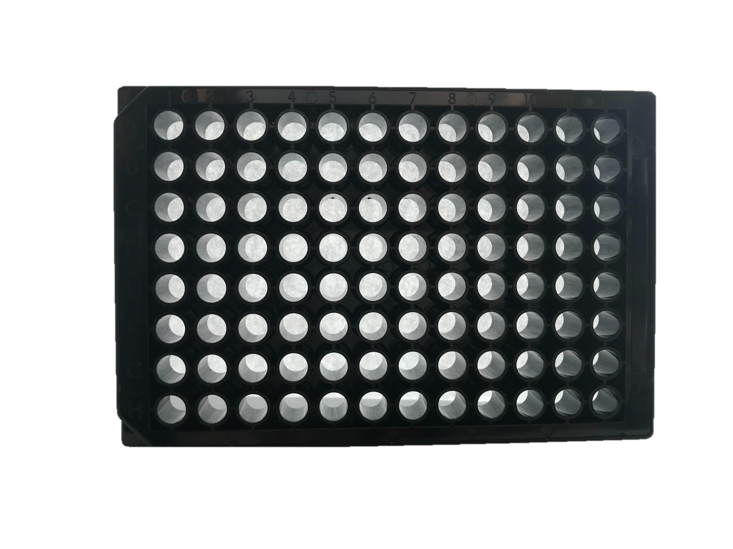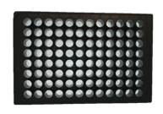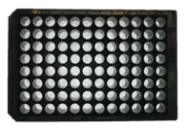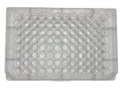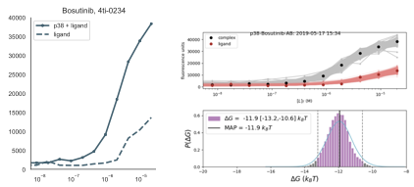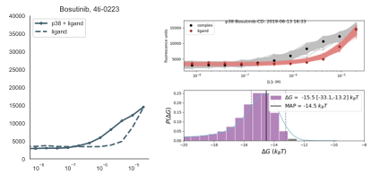

**B**

**Plate A**

**Plate D**

**Assaytools Results**

**Fluorescence Traces**

**C**